# Cuyahoga Template Development Guide

Contents

Cuyahoga Template Development Guide 1

Start with a plain html template 1

Convert the html template to a Cuyahoga template (ascx control) 2

Add Cuyahoga-specific elements to the template 2

Header elements 2

Content placeholders 3

Add menu’s 3

Change relative paths of images or links 4

Upload and install 4

Additional styles 8

This document shows how to create Cuyahoga templates from a plain html web site design. We’re assuming that you can create your own html or have someone to do this for you.

## Start with a plain html template

In this guide, we’ll take a very simple design, just to show how things work. The template has a header with a logo, a main menu and a two-column layout with a sub menu on the left.

HTML:

<!DOCTYPE html PUBLIC "-//W3C//DTD XHTML 1.0 Transitional//EN" "http://www.w3.org/TR/xhtml1/DTD/xhtml1-transitional.dtd">

<html xmlns="http://www.w3.org/1999/xhtml">

<head>

<title>My Cuyahoga site</title>

<meta http-equiv="Content-Type" content="text/html; charset=utf-8" />

<link rel="stylesheet" href="Style.css" type="text/css" />

</head>

<body>

<div id="container">

<div id="header">

<img src="Images/cuyahoga-logo.png" alt="Logo" style="vertical-align:middle" />

<span id="title">My Cuyahoga site</span>

</div>

<div id="mainmenu">

<ul>

<li><a href="#" class="selected">Menu item 1 (selected)</a></li>

<li><a href="#">Menu item 2</a></li>

<li><a href="#">Menu item 3</a></li>

<li><a href="#">Menu item 4</a></li>

</ul>

</div>

<!-- main -->

<div id="main">

<!-- sidebar -->

<div id="side">

<div id="submenu">

<ul>

<li><a href="#" class="selected">Submenu item 1</a></li>

<li><a href="#">Submenu item 2</a></li>

<li><a href="#">Submenu item 3</a></li>

<li><a href="#">Submenu item 4</a></li>

</ul>

</div>

<div id="sidecontent">

Sidebar content comes here.

</div>

</div>

<!-- main content area -->

<div id="maincontent">

Main content comes here

</div>

</div>

<!-- end main -->

</div>

</body>

</html>

This is how the plain html template looks:  
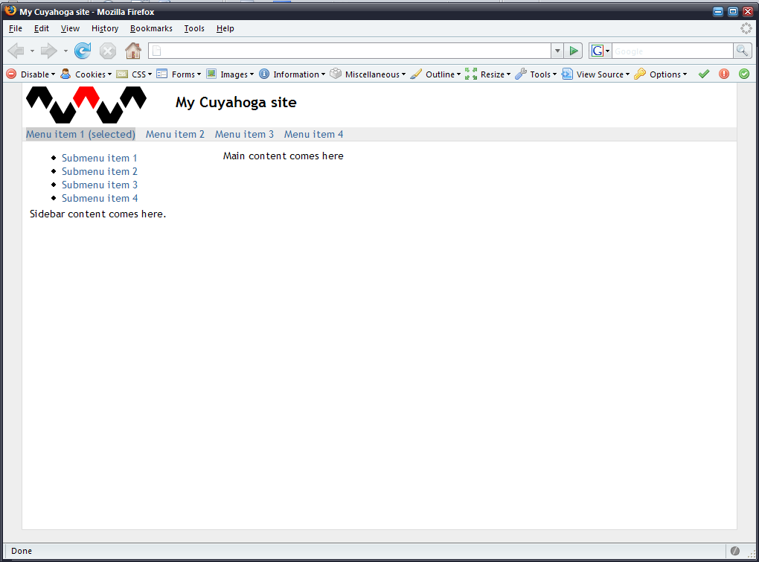

## Convert the html template to a Cuyahoga template (ascx control)

1. Rename the template .html file to an .ascx file
2. Add the following line to the top of the file:  
     
   <%@ Control Language="c#" AutoEventWireup="false" Inherits="Cuyahoga.Web.UI.BaseTemplate" %>
3. Add form tags (required for ASP.NET Web Forms) right after the <body> tag and just before the </body> tag:  
     
   <body>  
    <form id="t" method="post" runat="server">   
    <div id="container">  
    *SNIP TEMPLATE CONTENT*  
    </div>  
    </form>  
   </body>

## Add Cuyahoga-specific elements to the template

Cuyahoga needs a few specific elements in the template to make it work.

### Header elements

The <head> section of a Cuyahoga template should look like this:  
  
<head>

<title><asp:literal id="PageTitle" runat="server"></asp:literal></title>

<meta http-equiv="Content-Type" content="text/html; charset=utf-8" />

<asp:literal id="MetaTags" runat="server" />

<asp:literal id="Stylesheets" runat="server" />

<asp:literal id="JavaScripts" runat="server" />

</head>

### Content placeholders

One of the strong points of Cuyahoga is that its templates allow content on just about any place you want. Just throw in some ASP.NET placeholder controls and you’re done. These placeholders automatically show up when building pages with sections.

In our example we have two places where we want content to appear: the main area in the right column and the area in the side bar under the sub menu.

Originally, the html looked like:  
  
<!-- main content area -->

<div id="maincontent">

**Main content comes here**

</div>

With a placeholder it looks like:  
  
<!-- main content area -->

<div id="maincontent">

<**asp:placeholder id="maincontent" runat="server"></asp:placeholder>**

</div>

## Add menu’s

Cuyahoga comes with a few menu controls (ASP.NET user controls) that render a menu structure based on the page hierarchy. In this example, we are taking the NavigationLevelZeroOne.ascx control for the main menu and the NavigationLevelTwo.ascx control for the sub menu.

To use the user controls, we have to add the declaration to the top of the template first:  
  
<%@ Register TagPrefix="uc1" TagName="navigation" src="~/Controls/Navigation/NavigationLevelZeroOne.ascx" %>  
<%@ Register TagPrefix="uc2" TagName="subnavigation" Src="~/Controls/Navigation/NavigationLevelTwo.ascx" %>

Then, we can replace the dummy menu lists with the user controls.

Before:

<div id="mainmenu">

<ul>

<li><a href="#" class="selected">Menu item 1 (selected)</a></li>

<li><a href="#">Menu item 2</a></li>

<li><a href="#">Menu item 3</a></li>

<li><a href="#">Menu item 4</a></li>

</ul>

</div>

After:

<div id="mainmenu">

<uc1:navigation id="Nav1" runat="server"></uc1:navigation>

</div>

For the sub menu, we replace the dummy list with the other user control:

<div id="submenu">

<uc2:subnavigation id="Nav2" runat="server"></uc2:subnavigation>

</div>

It might be possible that the html output of the menu user controls isn’t what you really want (confliction id’s or redundant tags). To solve this, just edit the ascx menu controls so that the output is more to your liking. An alternative is to leave the default menu controls the same and build your own ascx menu controls and add these to the template. Taking the original user controls as an example, this should be easy for anybody with a little ASP.NET experience.

## Change relative paths of images or links

Because templates can be used in pages different url’s, relative links to images or other pages won’t work properly. We change these to links that are relative to the application root. For example, the image link of the logo should be changed from:

<img src="Images/cuyahoga-logo.png" …

to:

<img src='<%= ResolveUrl("~/Templates/MyTemplate/Images/cuyahoga-logo.png") %>' …

Note that we used ~/Templates/MyTemplate as the location where we are going to store the template on the server (see next section).

## Upload and install

So, we’ve finished our first template. Now it’s time to upload it to our server. In this example, the template is uploaded to the Cuyahoga server and stored in the /Templates/MyTemplate directory.

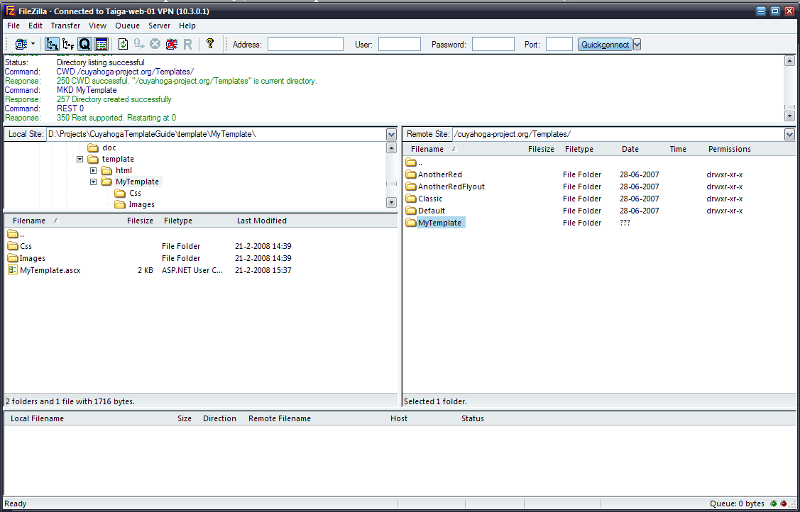

Of course, when developing your templates on your local machine, you can just copy the files, or work directly in the template directory.

After uploading the new template, we just have to register it in Cuyahoga and then, we’re ready to use it.

Login at your Cuyahoga site as administrator, go to the site administration and click ‘Manage Templates’ on the left. Next hit ‘Add new template’.

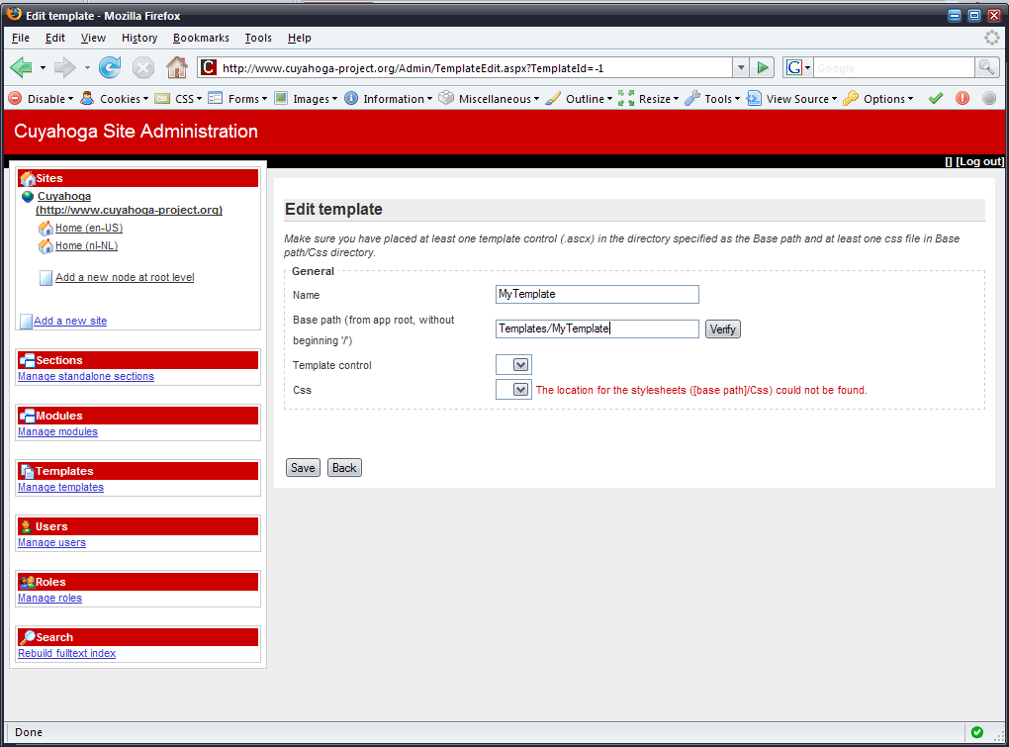

For the template name, enter the template name. For the base path, enter the path, relative from the Cuyahoga root where the template is stored. In this case, we uploaded the new template to Templates/MyTemplate, so we enter that as the base path. Clicking ‘Verify’ makes sure that there is at least one .ascx template control and one stylesheet file in the Css directory within your template directory.

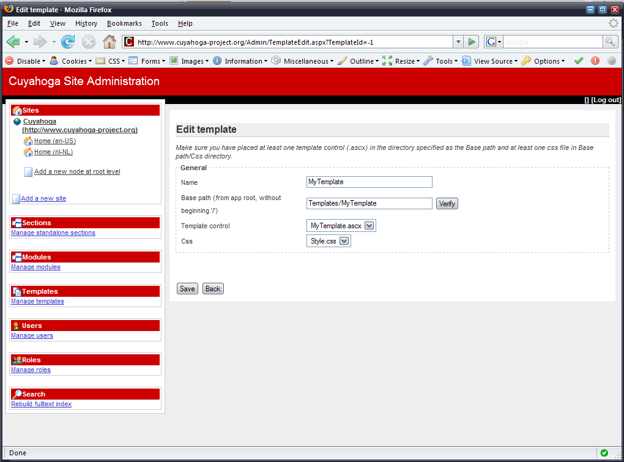

Hit ‘Save’ and the template is installed and ready for use!

Add a new node to your site and select the newly intalled template. You’ll see that the placeholders that you’ve added to the template automatically show up when adding a section.

The final result could look like this:

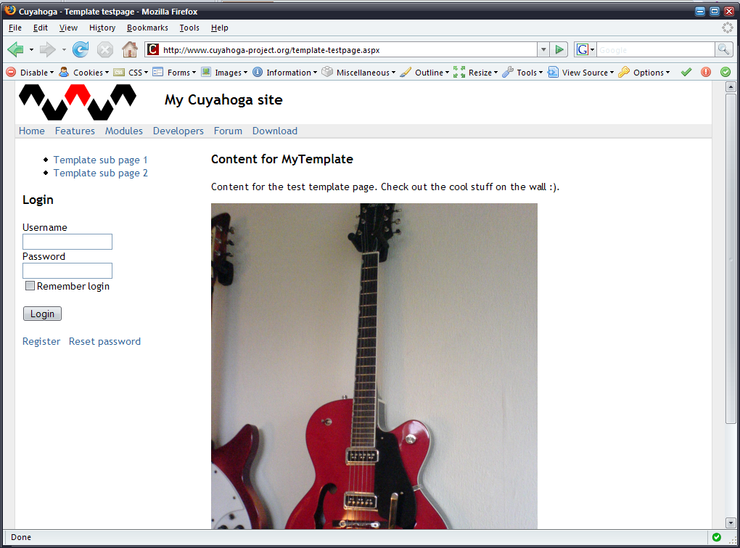

We added a test page on the live Cuyahoga site with the sample template and two sections; one with a StaticHtml module in the maincontent placeholder and one with a User module in the sidecontent placeholder.

## Additional styles

Cuyahoga outputs some default html. Every section section is surrounded with a div that has a CSS class ‘section’. The section title is in a <h3> tag. Add these to your template if you want to style these.

Some modules also output some specific html. For example, the Articles module outputs the list of articles as an unordered list (<ul>) and individual articles contain a <h4> tag as title and contain a div with the CSS class ‘articlesub’. You might also want to style these.

Check the stylesheet (red.css) in the AnotherRed template to get an idea of a stylesheet that styles all Cuyahoga and module output.